

CHG0XXXXXX

S-MRP (Shortage Prediction)
User Guildelines

Author: Vanessa Battung
Creation Date: August 12, 2026

Table of Contents

1. Application Interface Guidelines Error! Bookmark not defined.
2. Application Details Error! Bookmark not defined.

Overview

Purpose

The Shortage Monitoring & Prediction (S-MRP) Dashboard provides visibility into potential material shortages, inventory health, expiry risks, and procurement actions. The dashboard enables planners and buyers to proactively manage supply risks through automated digital workers and predictive analytics.

Intended Users

Material Planners

Buyers

Supply Chain Analysts

Production Planners

Operations Management

Application Interface

Dashboard Home Page

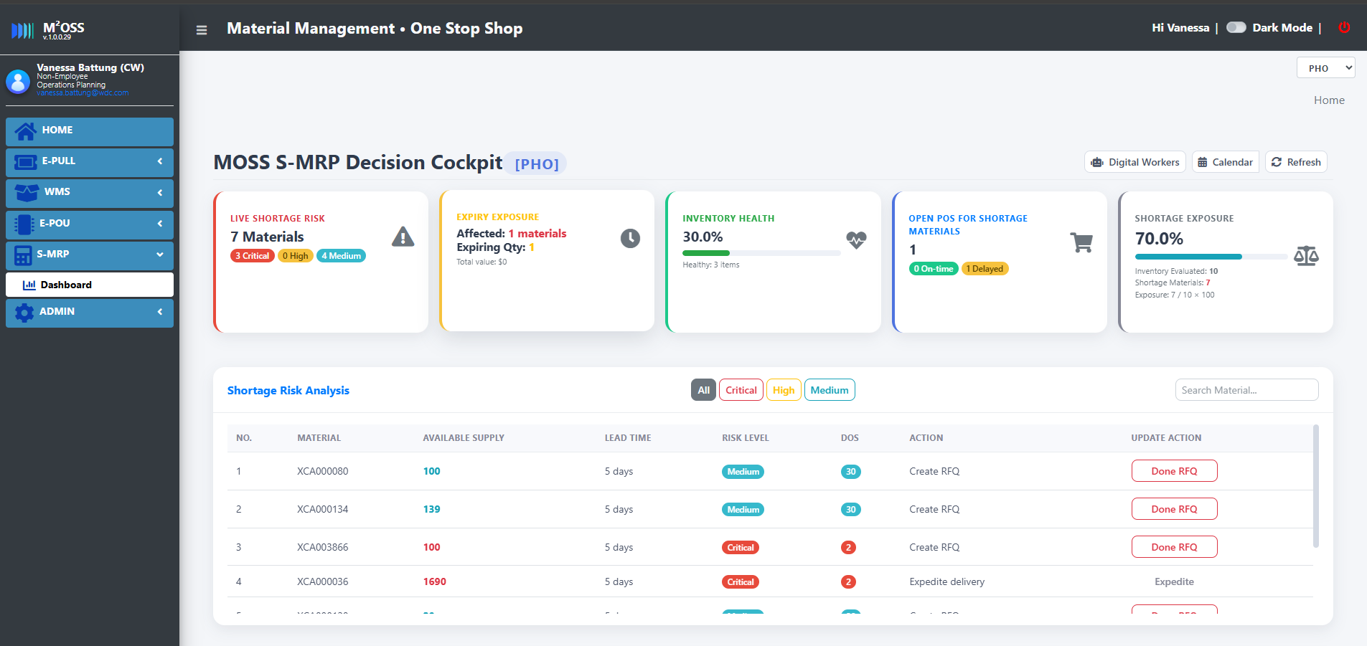

Dashboard Components

Component | Description
Site Selector | Select plant/site to view
Refresh Button | Reload latest dashboard data
Calendar | View historical dashboard results
Digital Workers | Access available digital workers
KPI Cards | View overall supply health indicators
Shortage Risk Table | Review materials with shortage risks
Activity Log | Review recent automated actions

Key Performance Indicators (KPIs)



Live Shortage Risk

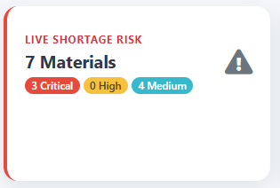

Risk Levels

Level | Description
Critical | Material will run out within lead time
High | Material approaching shortage
Medium | Potential future shortage

Expiry Exposure

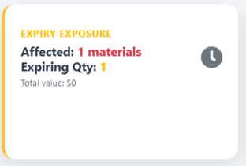

Displays:

Number of affected materials

Total expiring quantity

Inventory at risk of expiration

Inventory Health

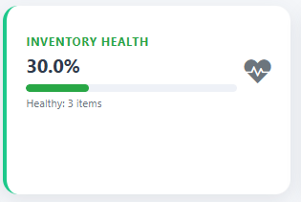

Displays:

Healthy inventory percentage

Number of healthy materials

Formula:

Inventory Health % = Healthy Materials / Total Evaluated Materials x 100

3.4 Open POs for Shortage Materials

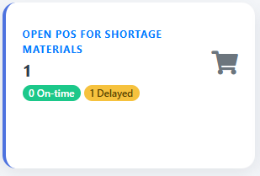

Displays:

Total Open Purchase Orders

On-Time POs

Delayed Pos

This metric helps identify shortages caused by delayed supplier deliveries.

Shortage Exposure

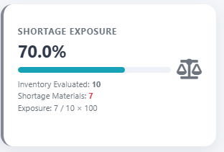

Displays:

Shortage Exposure = Shortage Materials / Total Inventory Materials

Shows the overall percentage of materials at risk.

4. Shortage Risk Analysis

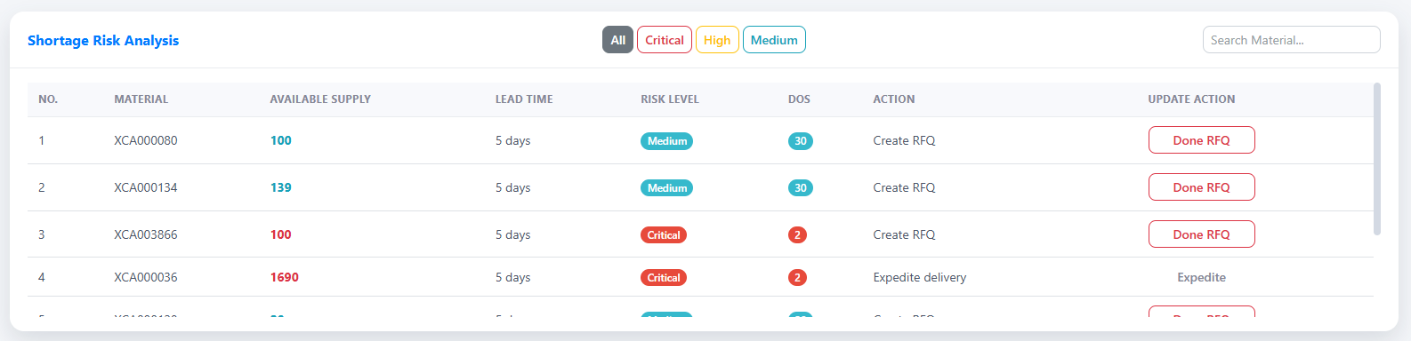

Description

The Shortage Risk Analysis table lists all materials predicted to experience shortages.

Columns

Column | Description
Material | Material Number
Available Supply | Current available inventory
Lead Time | Procurement lead time
Risk Level | Critical / High / Medium
DOS | Days of Supply
Action | Recommended system action
Update Action | User confirmation action

4.1 Filtering Shortages
Users can filter materials by:
- All
- Critical
- High
- Medium

4.2 Searching Materials
Enter a material number in the search box to locate a specific material.

5. Recommended Actions
The system may recommend one of the following actions:

Action | Description
Create PR | Purchase Requisition should be created
Create RFQ | Buyer should request supplier quotation
Expedite Delivery | Existing PO delivery should be expedited
Review Planning Profile | Review planning parameters

Mark Action as Completed
After performing the recommended action:

For Purchase Requisition
- Locate material record.
- Click Done PR.
- Confirm the action.
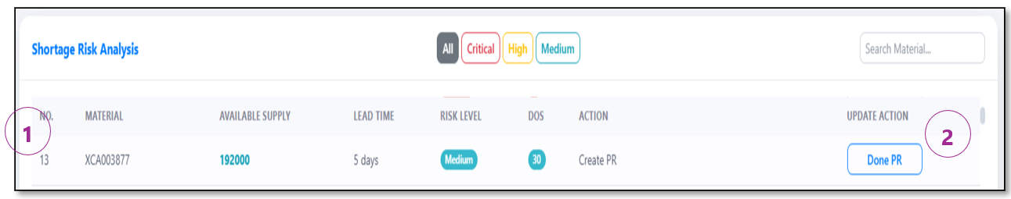
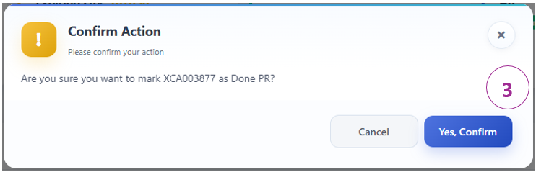

For RFQ
- Locate material record.
- Click Done RFQ.
- Confirm the action.

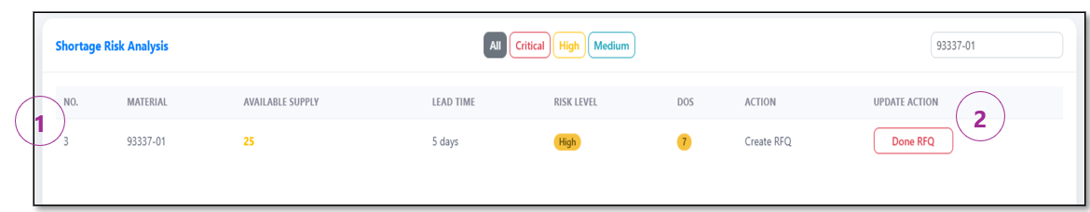

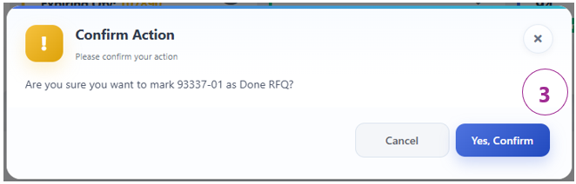

6. Digital Workers

- Click Digital Workers button.
- Digital Workers modal appears

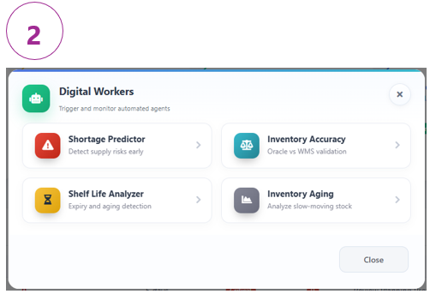
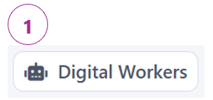



The dashboard provides automated Digital Workers to assist supply chain monitoring.
Available Workers

Shortage Predictor
Predicts future shortages based on:
- Inventory
- Demand
- Open Purchase Orders
- Lead Times

Inventory Accuracy Monitor
Compares Oracle inventory data against WMS inventory records.

Shelf Life Analyzer
Identifies materials nearing expiration.

Inventory Aging Analyzer
Detects slow-moving inventory and aging stock.

7. Running the Shortage Predictor
Insert screenshot of Shortage Predictor modal.

Option 1: Scan All Materials
- Click Digital Workers.
- Select Shortage Predictor.
- Select Scan All Materials.
- Click Run Worker.






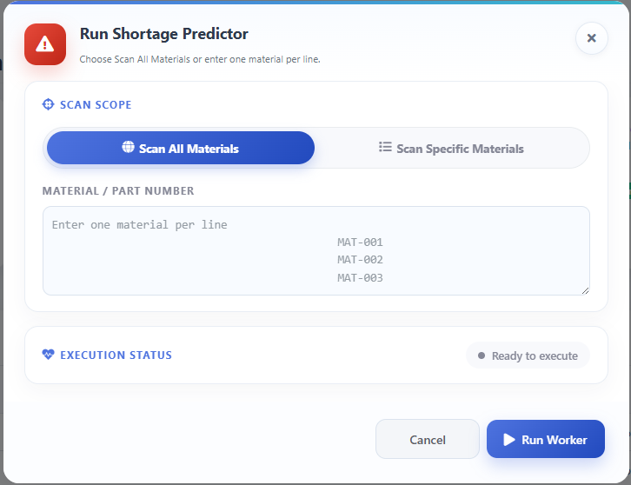

Scan Specific Materials → textbox disabled.
The system will process all materials for the current site.

Option 2: Scan Specific Materials
- Click Digital Workers.
- Select Shortage Predictor.
- Select Scan Specific Materials.
- Enter one material per line.
- Click Run Worker.


Example:





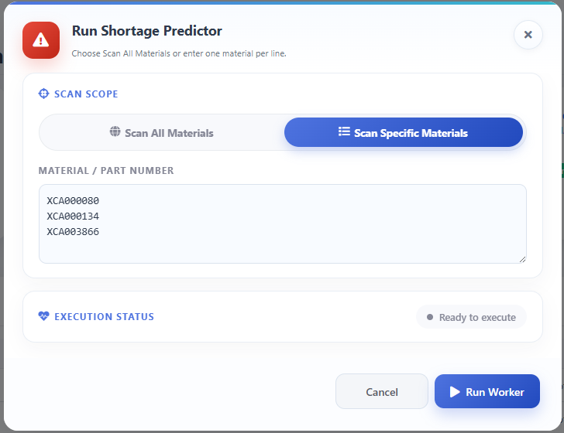

Scan Specific Materials → textbox enabled.
The system will process specific materials for the current site.

Execution Status
The status section displays:
Status | Meaning
Ready | Worker is ready
Running | Processing
Completed | Execution successful

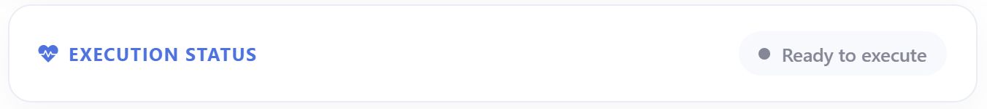
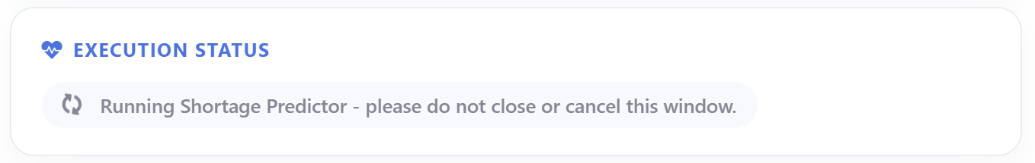
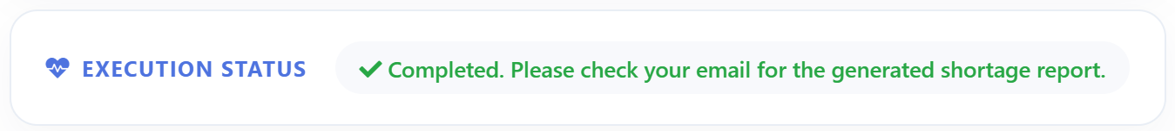

8. Historical Dashboard View
The dashboard will display ‘Shortage metrics’, ‘Inventory health’, ‘Expiry exposure’, ‘Open Pos’, ‘Digital Worker’s Activity’ for the selected date.

Viewing Historical Results
- Click Calendar.
- Select a date.
- Review the dashboard snapshot for the selected day.
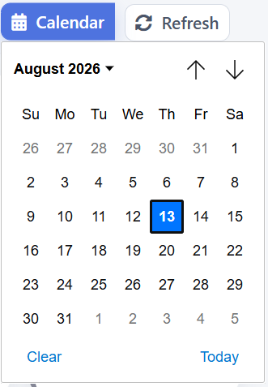




9. Digital Worker Activity Log
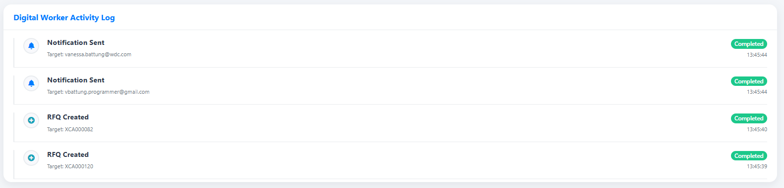
The Activity Log records automated system activities.
Examples:
- Shortage Predictor Executed
- Purchase Requisition Created
- RFQ Created
- Notification Sent
- Dashboard Updated
Users can use the log for audit and monitoring purposes

